**REST API Request testing using Postman**

1. Pre-requisite
   1. Latest version of Postman installed on your system – I have used Postman 6.2.4 for this exercise
   2. Sample REST APIs – I have used <https://reqres.in/> where couple of sample REST Requests are available for testing
   3. Jenkins war file to run Postman collection through Jenkins
2. Add REST API Requests in Postman
   1. Open Postman
   2. Create new Workspace TestWS1
   3. Create new Collection Collection1
   4. Create 2 folders inside Collection1
      1. GET – Create 2 GET request inside it and
      2. POST – Create 1 POST request inside it

The collection will look like this:

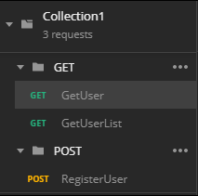

GetUser request: {{url}}/api/users/2

GetUserList request: {{url}}/api/users?page=2

RegisterUser request: {{url}}/api/users?page=2

Here url is a variable declared in collection. You can declare variables as Global and Environment types

Some of Javascripts code added are:

let baseUrl = pm.variables.get("url");

console.log("Value of Url is: " + baseUrl);

pm.variables.set("name", "Postman");

console.log(pm.variables.get("name"));

let globalvarName = pm.globals.get("name");

console.log(globalvarName);

* 1. Run REST API Request as Request

e.g. Run GetUserList request and verify Response and Assertions

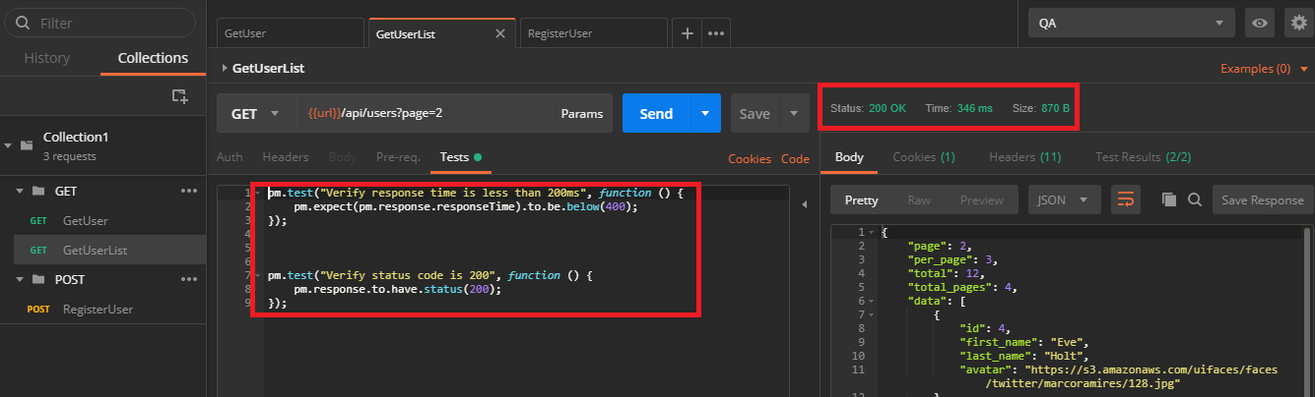

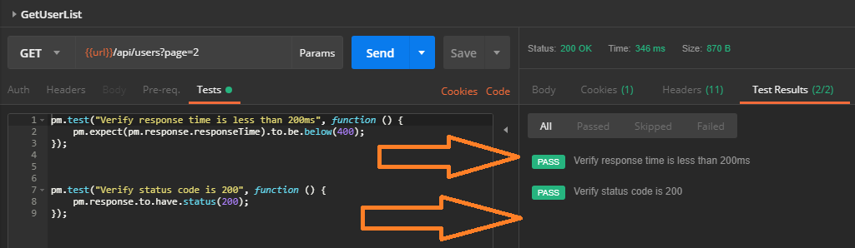

* 1. Run REST API Request as Collection Runner

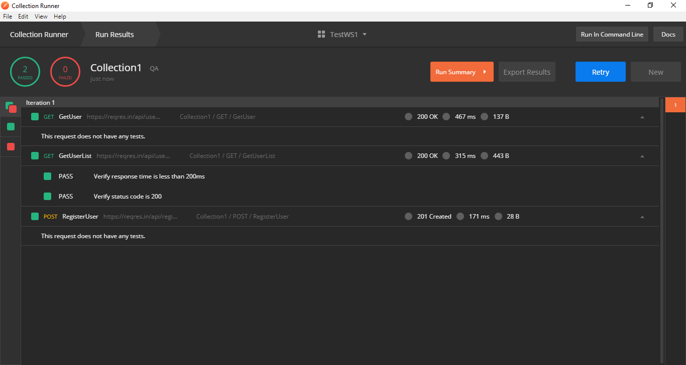

1. Run Postman Tests from Command Line
   1. Install node.js
   2. Install Newman using command

***npm install –g newman***

* 1. Export collection as json file

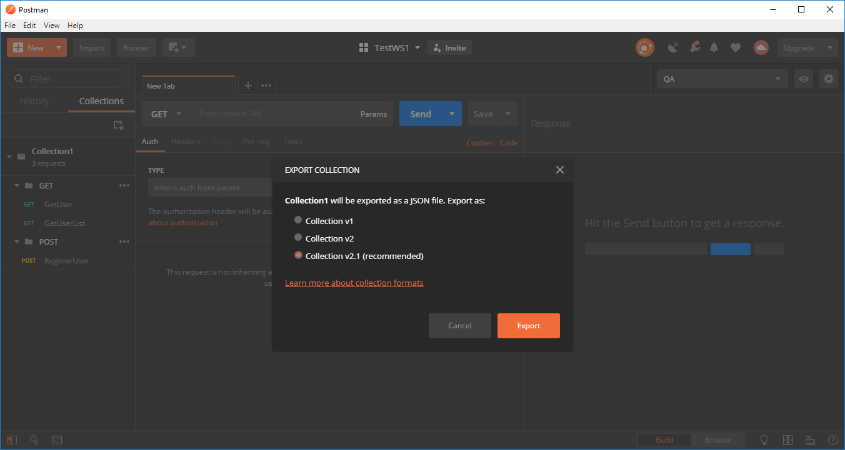

* 1. Run the exported collection from command line as

Newman run <collection.json>

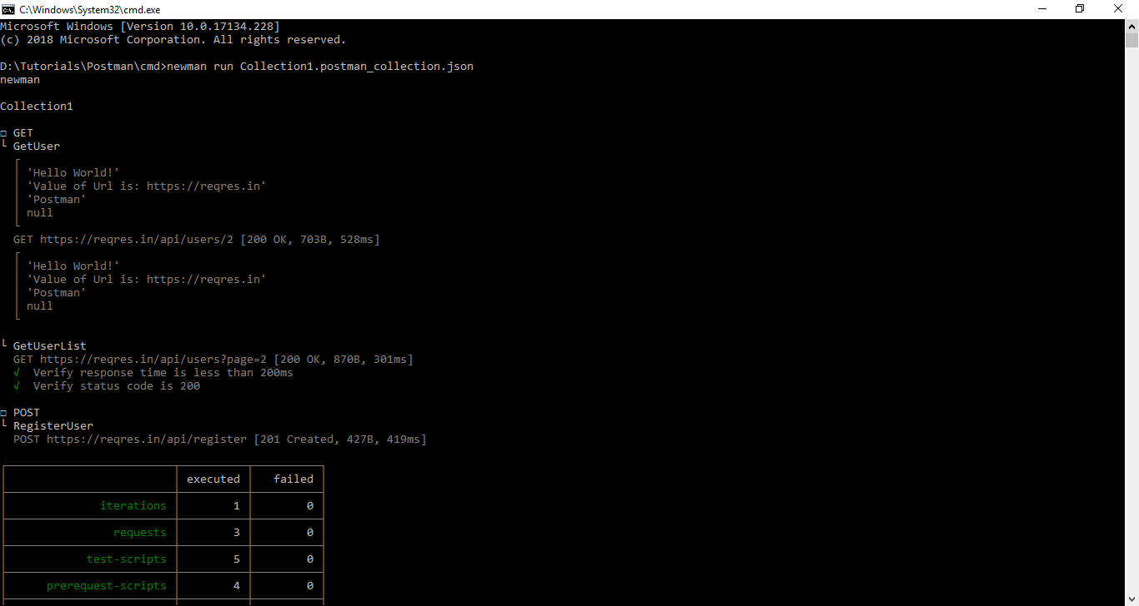

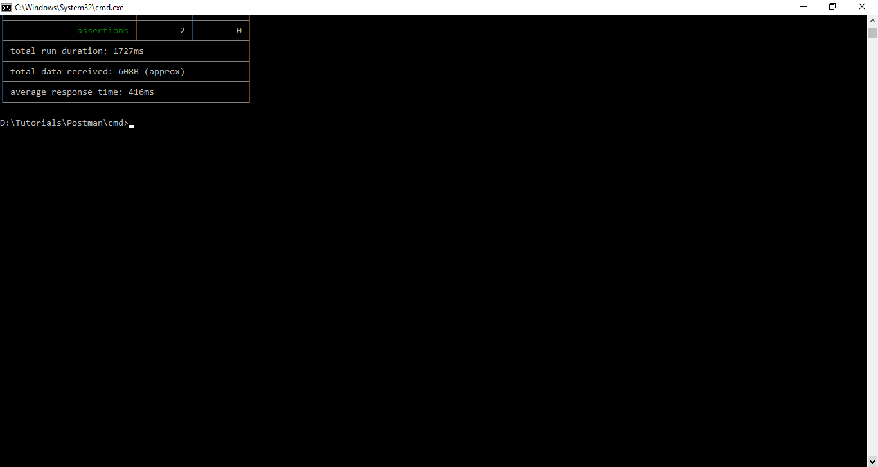

1. Run Postman tests from Jenkins
   1. Start Jenkins and create Freestyle project and configure the project as shown below:

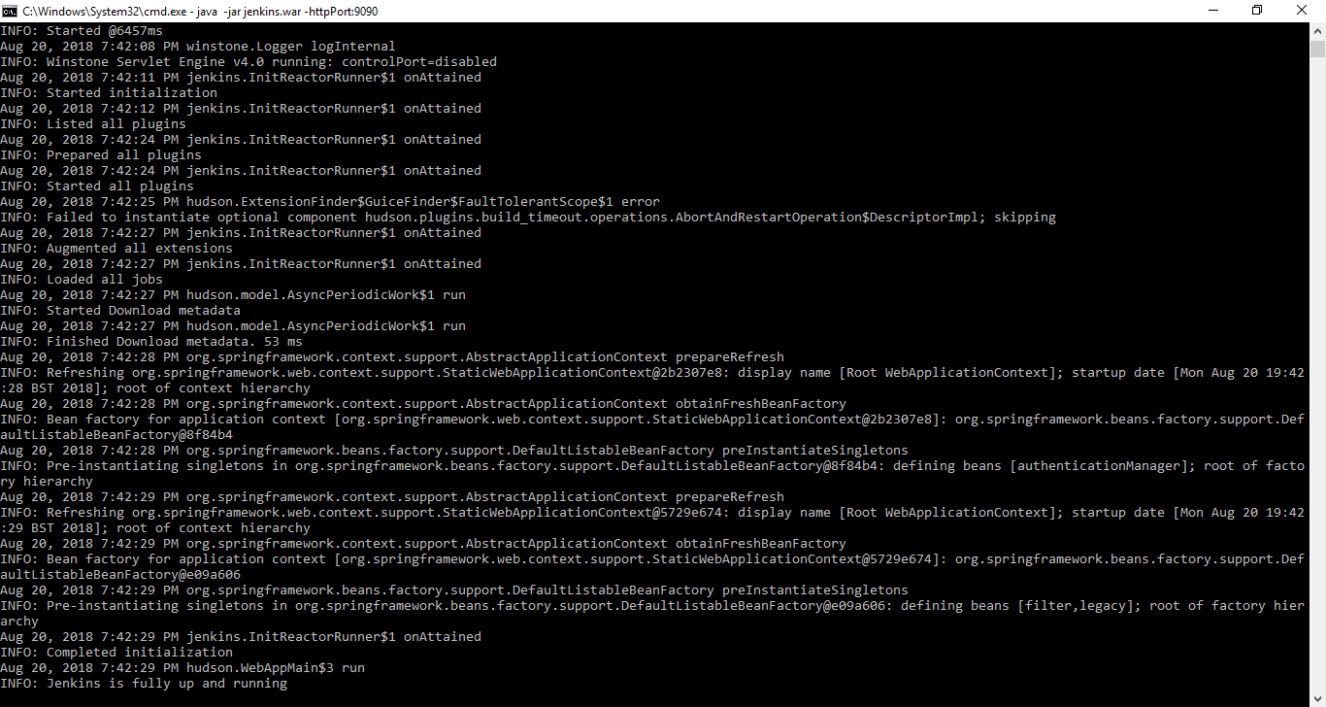

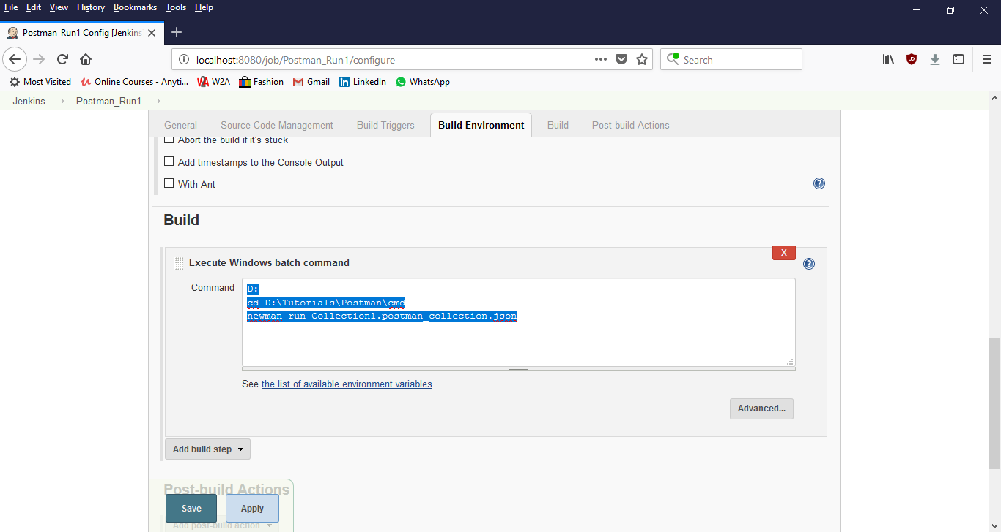

* 1. Build the project and view the Console output

